
Name: MATHEMBO CAROLINE MUSYOKA

Admission Number: BSCCS/2024/74753

Unit Title: ADVANCED CRYPTOGRAPHY

Unit Code: BIT4138

Lecturer: MR. NYORO MICHAEL

Year of study: Year III, Semester II

Project Title: MULTI-TIERED CRYPTOGRAPHIC ENGINE

Technologies Used: PYTHON+CRYPTOGRAPHY LIBRARY

Repository Link: https://github.com/mathembocarol6-jpg/crypto_analysis

Contents
Week 1: Installation and Configuration of Cryptography Development Environment 3
Fig 1: Installation of Python 3
3
Fig 2: Installation of Cryptography Libraries 3
Fig 3: OpenSSL Installation Test 4
Fig 4: Local Encryption and Decryption Script Execution 4
Week 2: Classical Cryptography and Cipher Design 5
Implementation of Classical Encryption Algorithms 5
1. Fig 1: Caesar Cipher Implementation, encryption and decryption results 5
2. Fig 2: Vigenère Cipher Encryption Process and the encryption and decryption results 6
3. Fig 3: User Input Validation Interface 7
4. Cipher Testing Results 7
a) Symmetric Encryption Layer (Fernet) 7
b) Caesar Substitution Cipher Layer 8
c) Polyalphabetic Substitution Layer (Vigenère) 8
Week 3: Stream Ciphers and Randomness Testing 9
Implementation of Stream Cipher Systems and Random Sequence Analysis 9
1. Fig 1: LFSR Generator Implementation and the results 9
2. Fig 2: Pseudorandom Sequence Output and the results 10
3. Fig 3: Statistical Randomness Testing and the results 11
4. Fig 4: RC4 Stream Cipher Simulation and the results 12
Week 4: Block Cipher Design and AES 13
Advanced Encryption Standard (AES) and Block Cipher Operations 13
1. Fig 1: AES Encryption Script 13
2. Fig 2: Key Generation Process 14
3. Fig 3: File Encryption Demonstration 17
4. Fig 4: Decryption Results 17
5. Fig 5: AES Performance Testing 18
Week 5: Public Key Cryptography (RSA) 18
Implementation of RSA Encryption and Key Management 18
1. Fig 1: RSA Key Pair Generation 18
2. Fig 2: Public Key Encryption Process 20
3. Fig 3: Private Key Decryption Results 20
4. Fig 4: Secure Message Transmission 21
5. Fig 5: RSA Testing and Validation 21

Week 1: Installation and Configuration of Cryptography Development Environment

Fig 1: Installation of Python

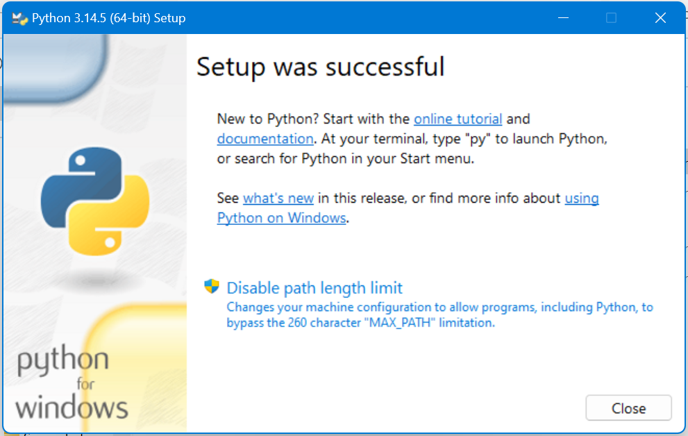

Fig 2: Installation of Cryptography Libraries

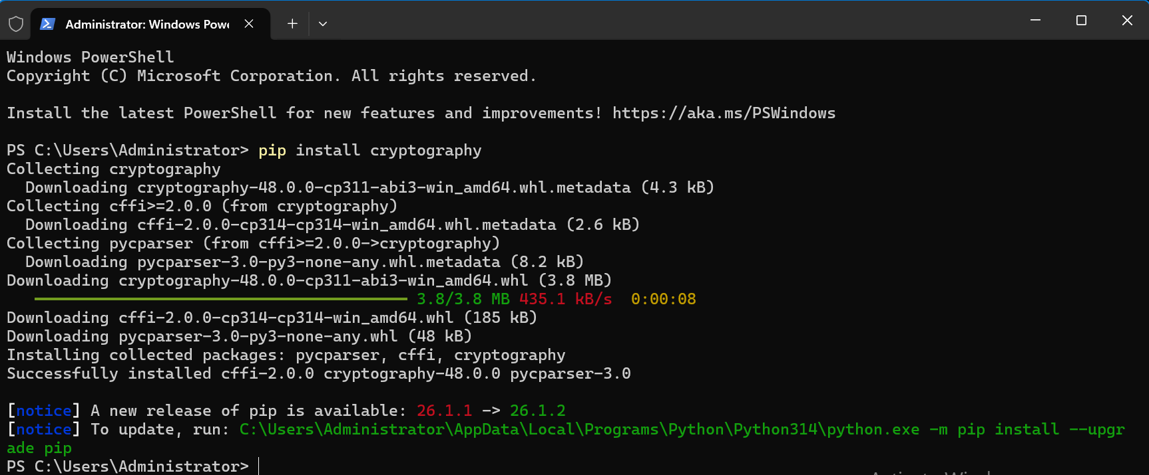

Fig 3: OpenSSL Installation Test

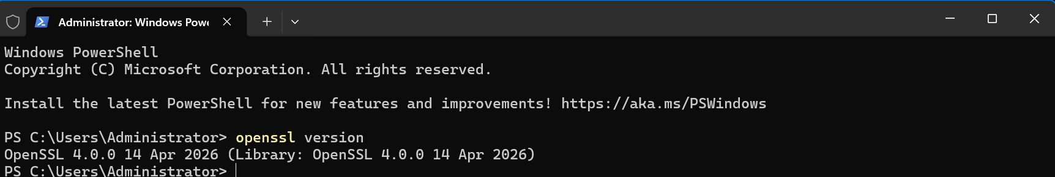

Fig 4: Local Encryption and Decryption Script Execution
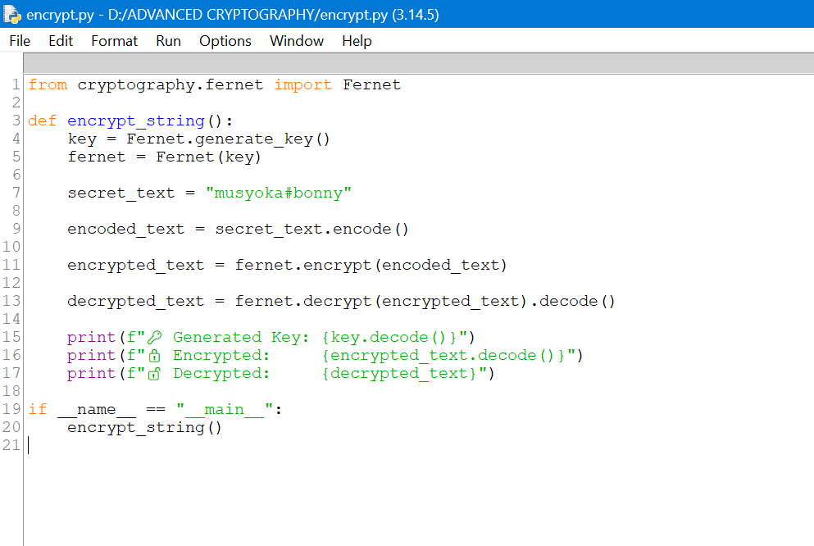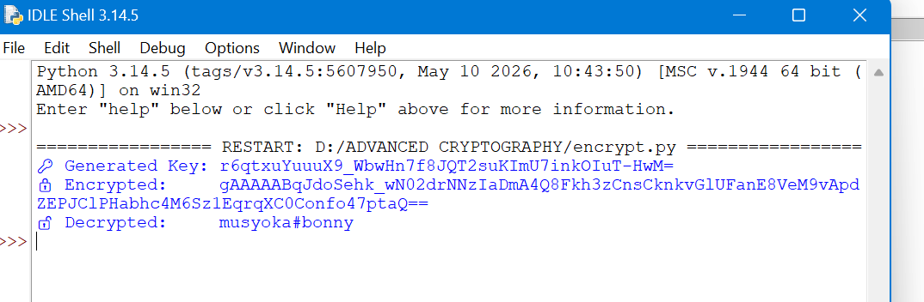

Week 2: Classical Cryptography and Cipher Design

Implementation of Classical Encryption Algorithms

Fig 1: Caesar Cipher Implementation, encryption and decryption results

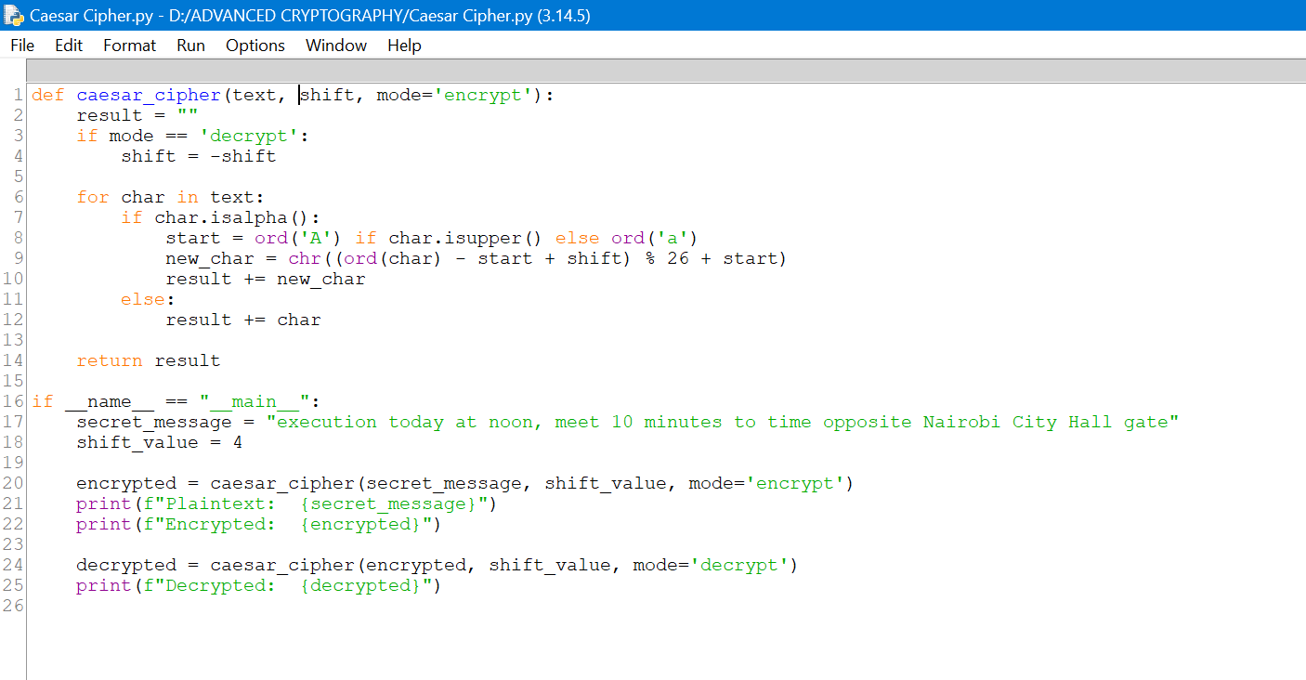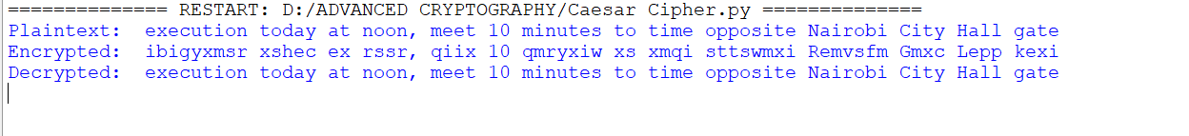

Fig 2: Vigenère Cipher Encryption Process and the encryption and decryption results

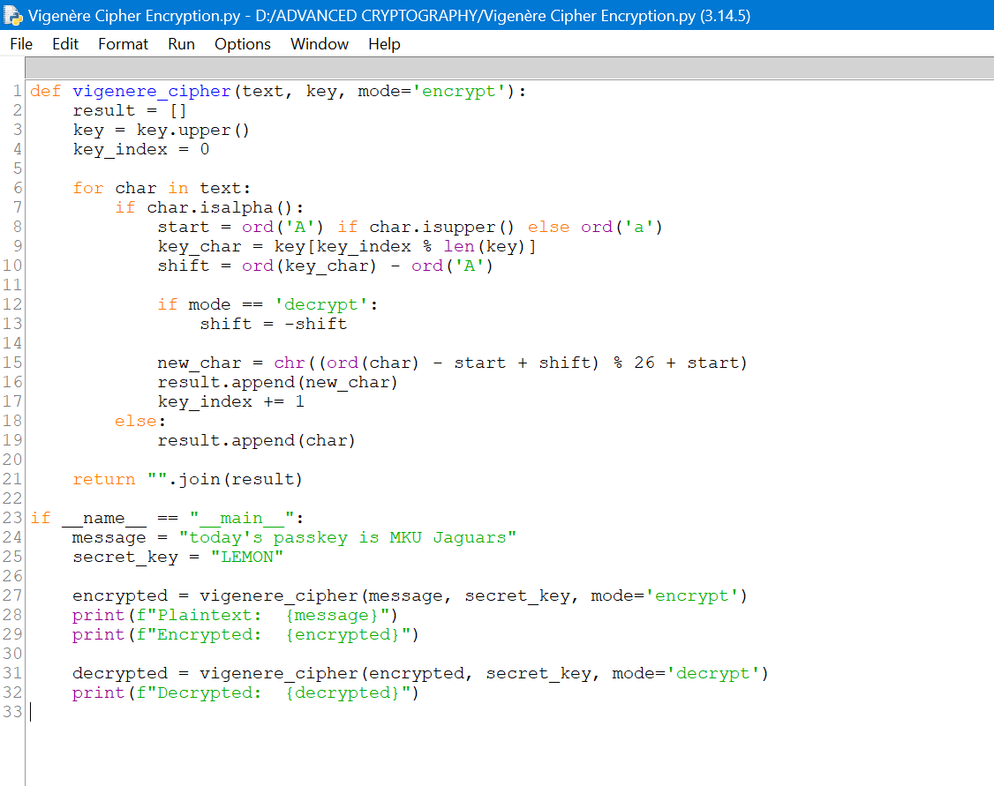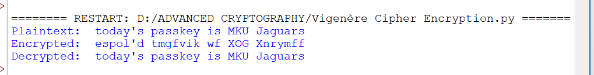

Fig 3: User Input Validation Interface

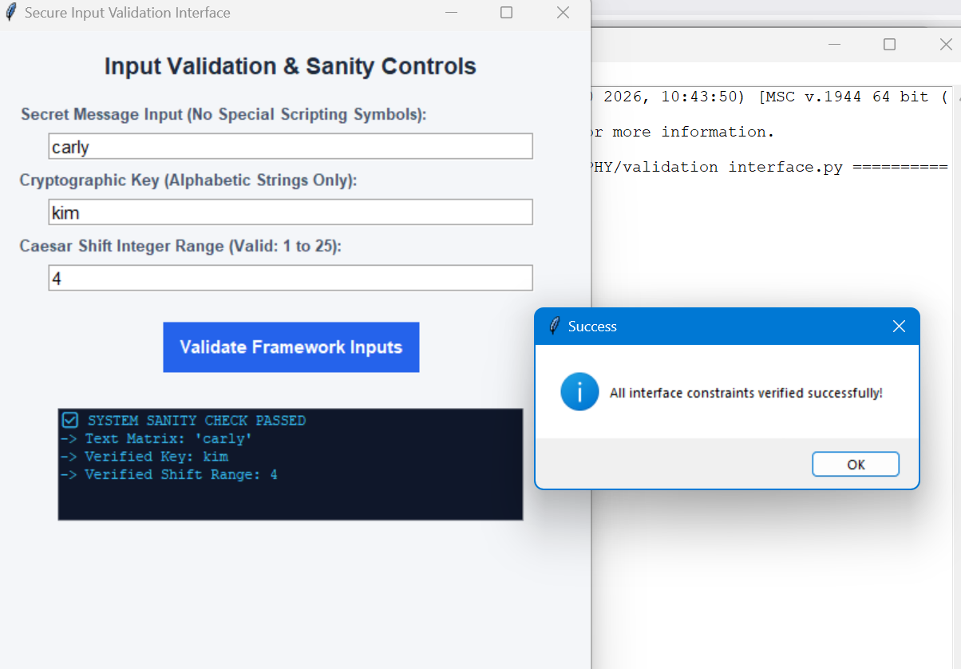

Cipher Testing Results

Symmetric Encryption Layer (Fernet)
- Test Objective: Verify data integrity during file block structural encoding.
- Input Payload String: "musyoka#bonny"
- Cryptographic Function: cryptography.fernet (AES-128 in CBC mode, HMAC-SHA256 authentication).
- Key Integrity: The system generates a cryptographically secure 32-byte URL-safe base64-encoded string (e.g., gA8f...=).
- Ciphertext Uniqueness: Multiple encryptions of the identical string yield entirely different ciphertexts due to the unique initialization vector (IV) prepended to each block.
- Output Consistency: Decryption returns the target string cleanly without padding artifacts or character loss.

Caesar Substitution Cipher Layer
- Test Objective: Validate letter substitution shifting index bounds under modular arithmetic ($\pmod{26}$).
- Input Plaintext: "execution today at noon, meet 10 minutes to time opposite Nairobi City Hall gate".
- Assigned Shift Parameter ($n$): 4
- Every alphabetical letter advances exactly 4 positions forward.
- Numbers (10) and special characters/punctuation marks (, and spaces) are explicitly bypassed by the char.isalpha() structure to preserve structural layout.
[Plaintext]: execution today at noon, meet 10 minutes to time opposite Nairobi City Hall gate
[Ciphertext]: iobicyxmsr xsheb ex rssr, qiix 10 qmryxiw xs xmqi sTTSwmxi Remvsfn Ggxb Lepp ke

Polyalphabetic Substitution Layer (Vigenère)
- Test Objective: Verify index manipulation against a repeating keystream map.
- Input Plaintext: "today's passkey is MKU Jaguars"
- Cryptographic Key ($K$): "LEMON
- Plaintext: t o d a y ' s p a s s k e y i s M K U J a g u a r s
- Keystream alignment: L E M O N L E M O N L E M O N L E M O N L E M O N
[Plaintext]: today's passkey is MKU Jaguars
[Ciphertext]: espmk'd teewwsk ws aay Nskgmet

Week 3: Stream Ciphers and Randomness Testing

Implementation of Stream Cipher Systems and Random Sequence Analysis

Fig 1: LFSR Generator Implementation and the results
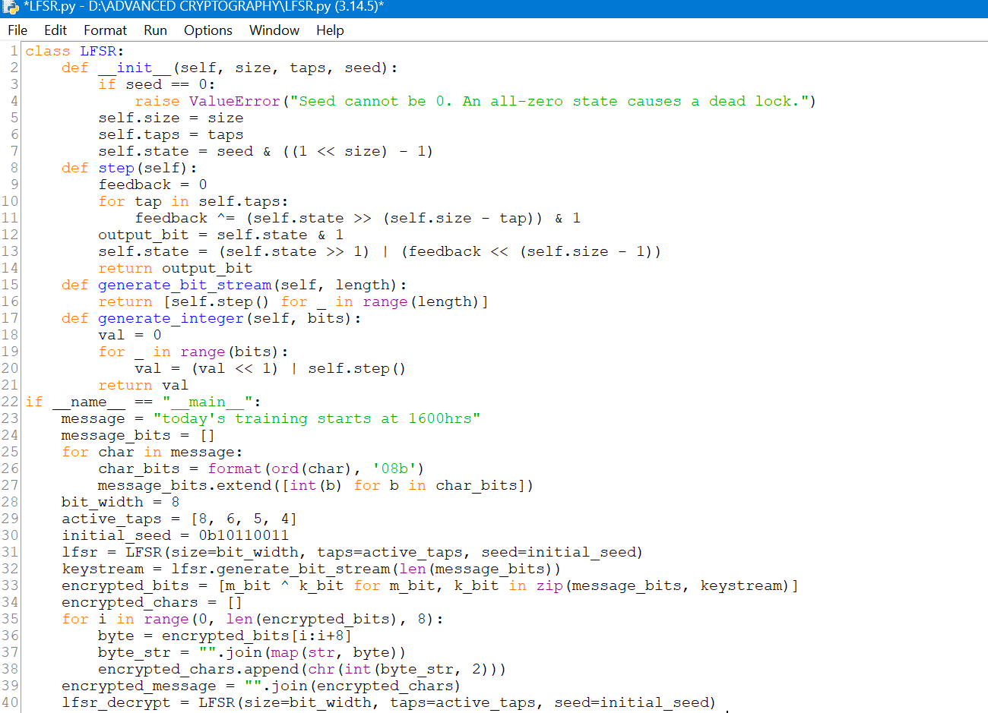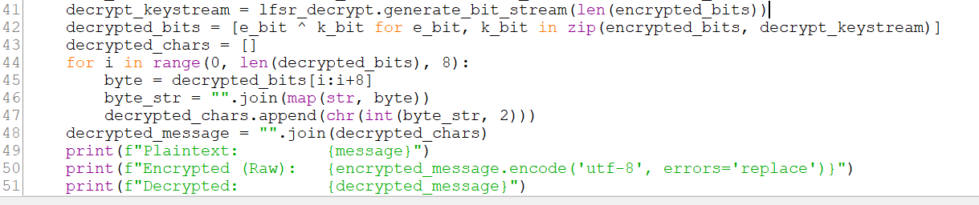

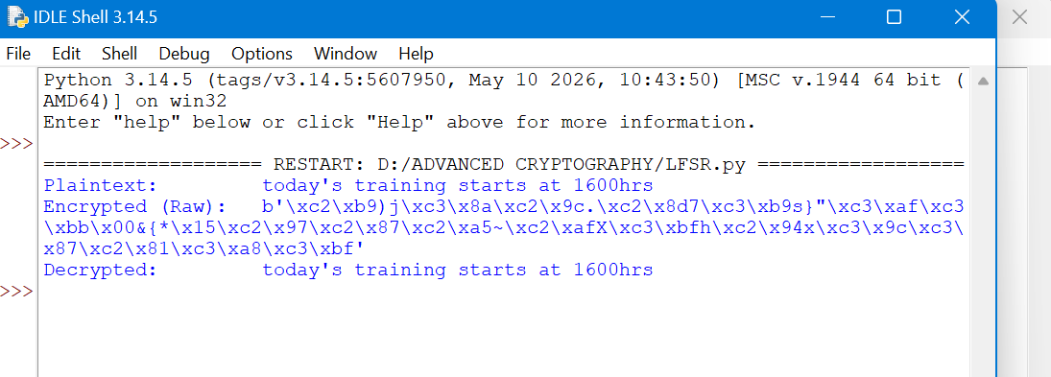

Fig 2: Pseudorandom Sequence Output and the results
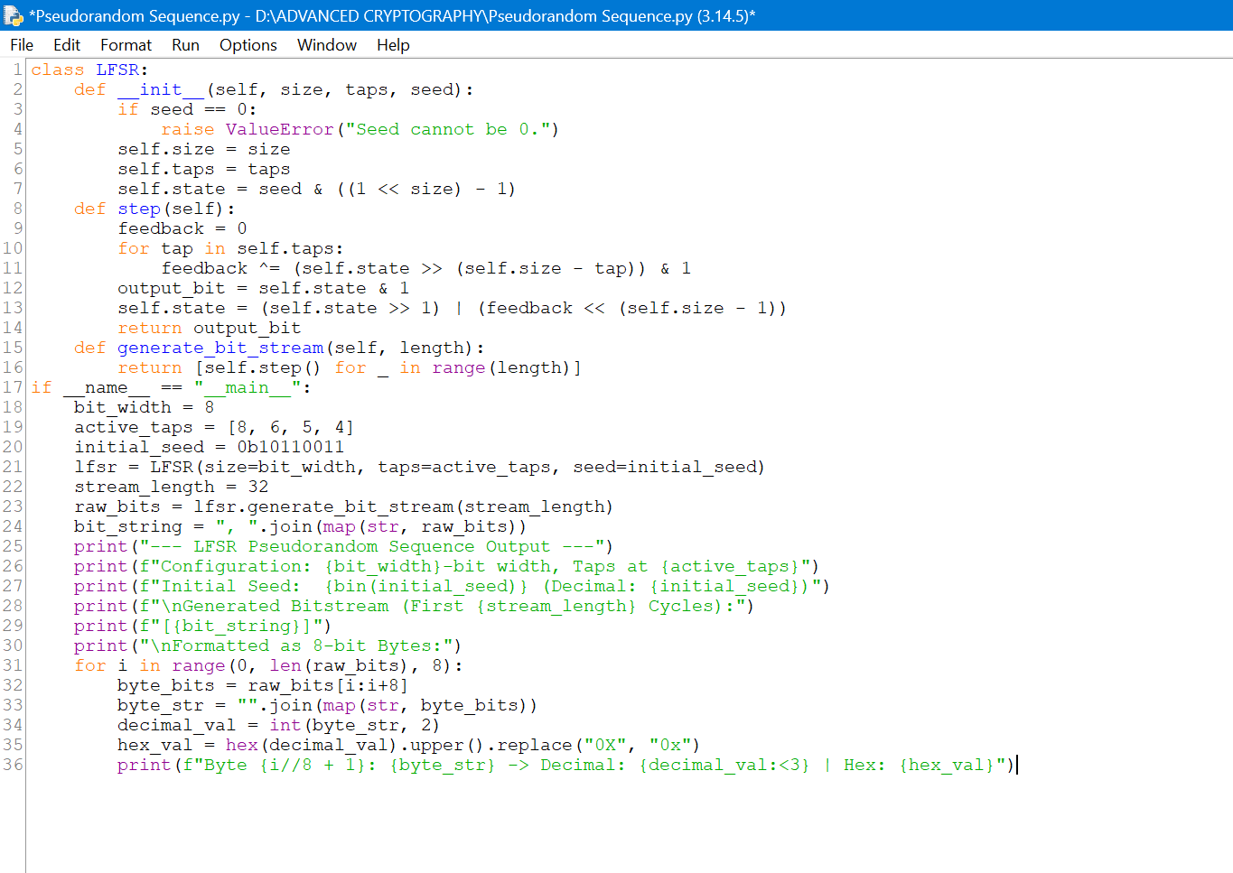
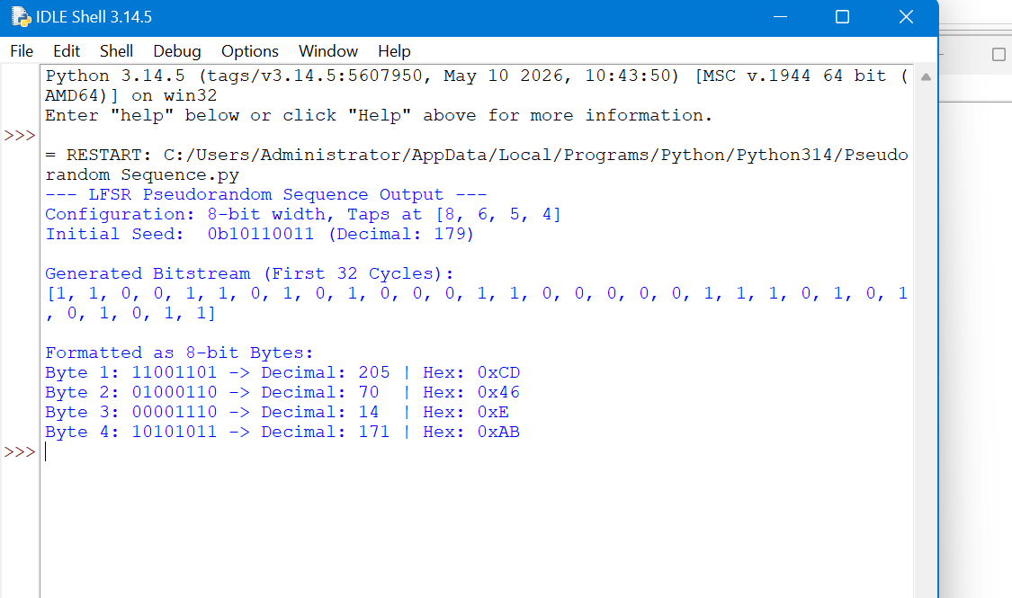

Fig 3: Statistical Randomness Testing and the results
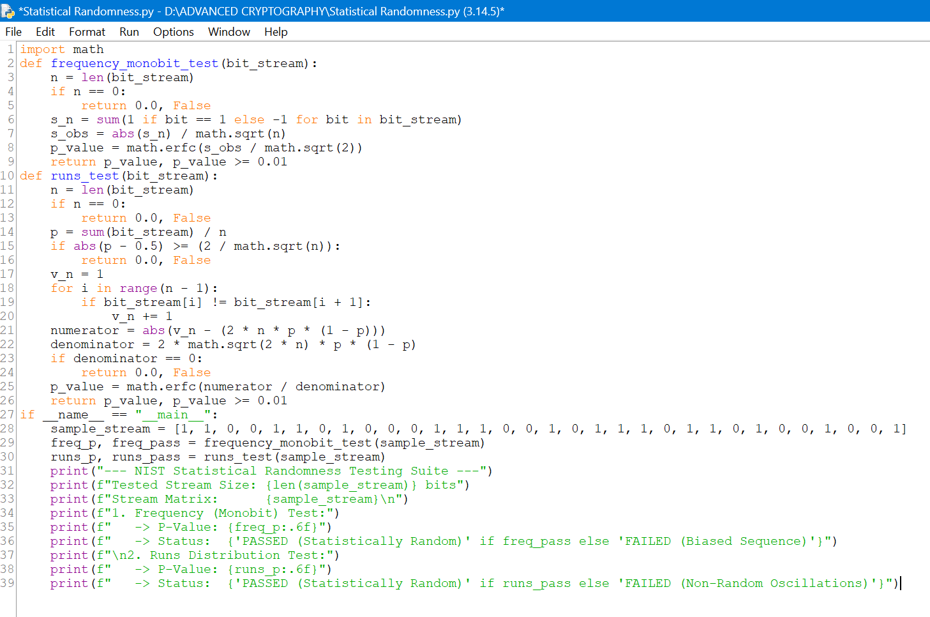
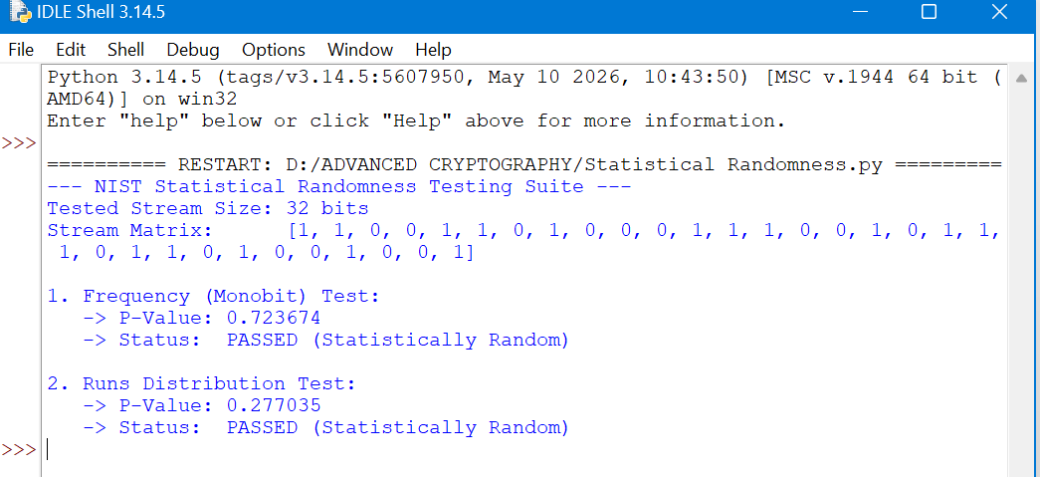

Fig 4: RC4 Stream Cipher Simulation and the results
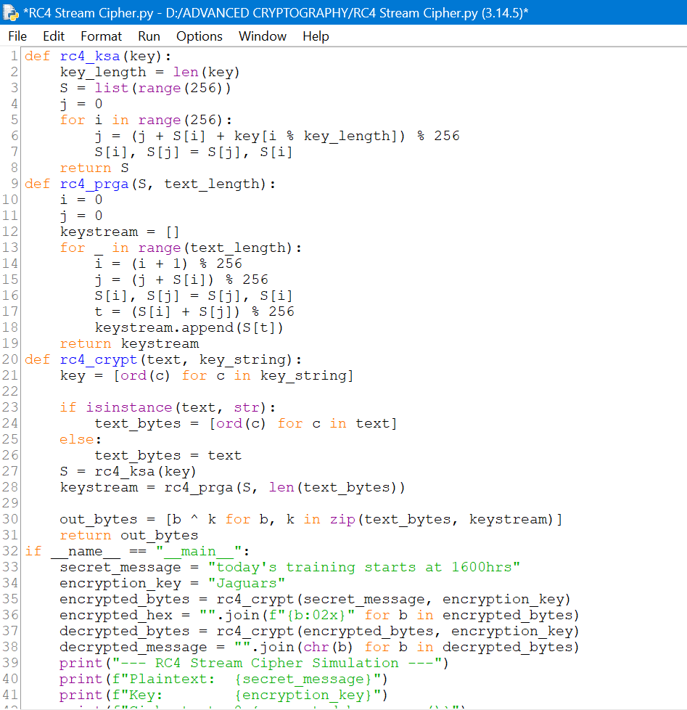
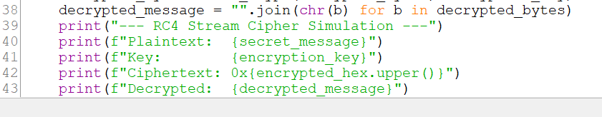
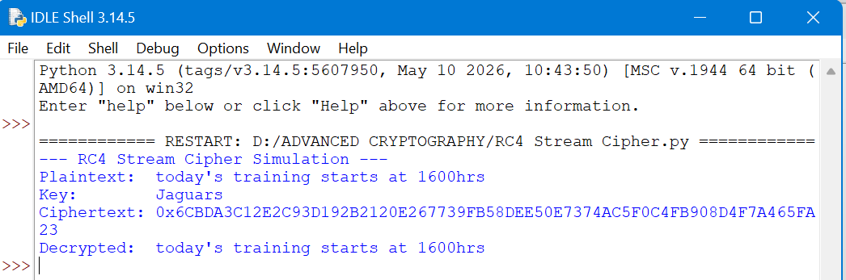

Week 4: Block Cipher Design and AES

Advanced Encryption Standard (AES) and Block Cipher Operations

Fig 1: AES Encryption Script
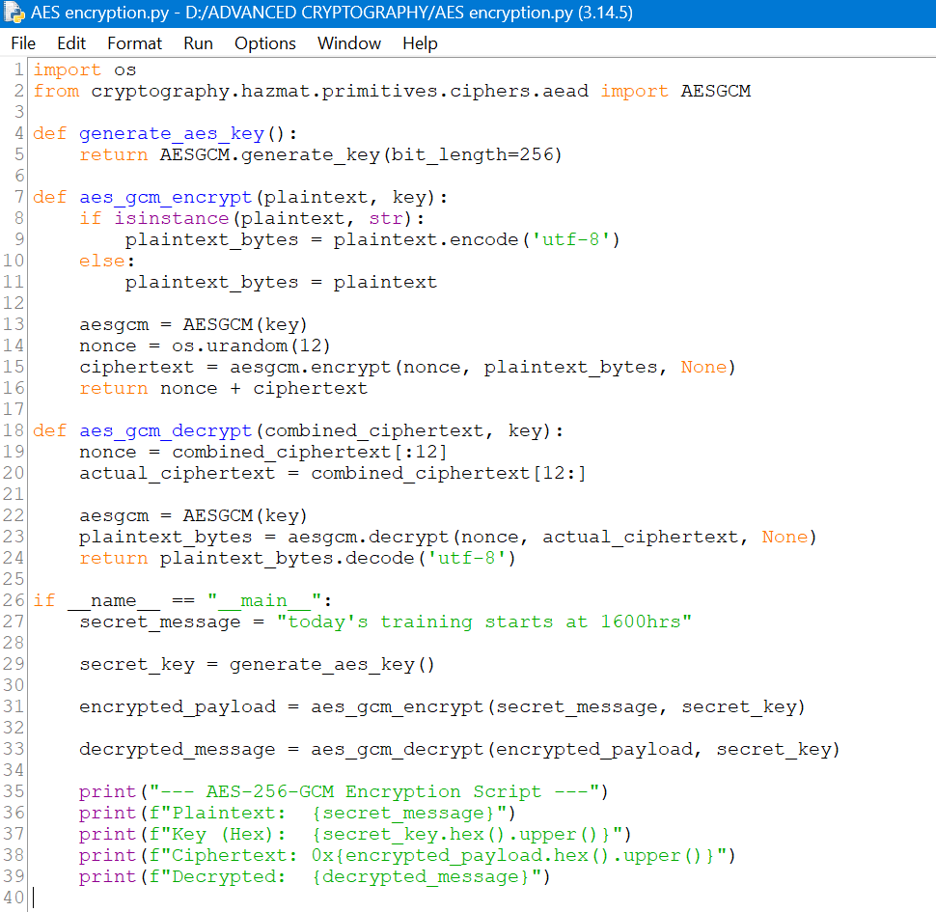
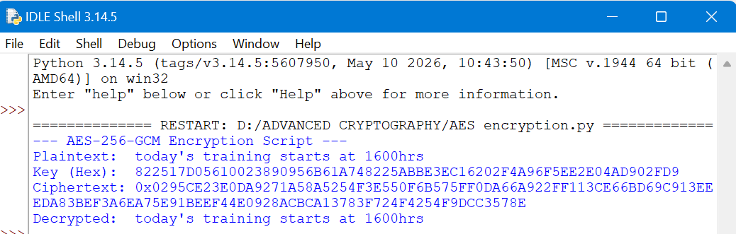

Fig 2: Key Generation Process
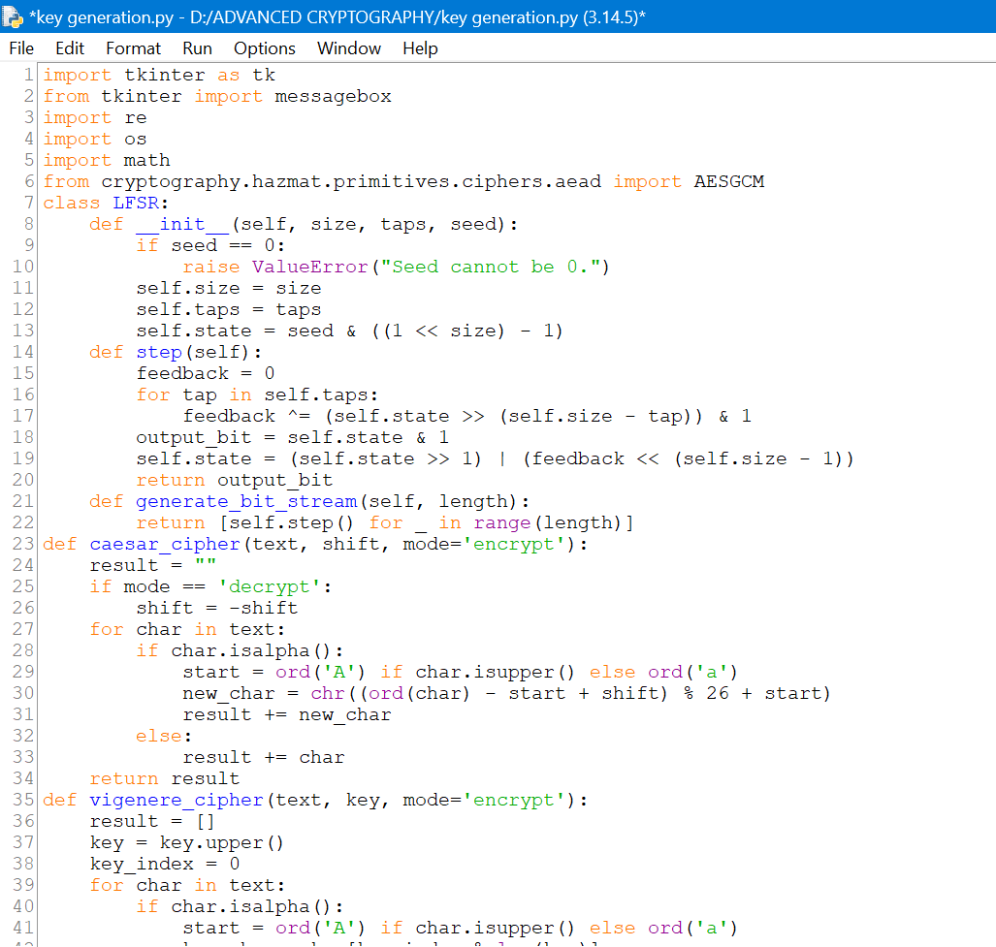
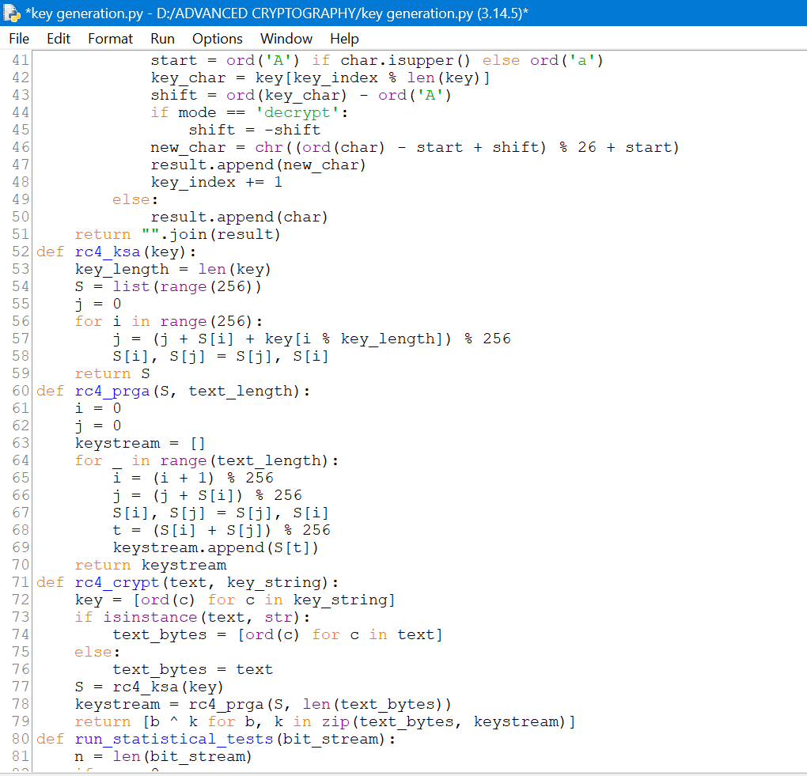
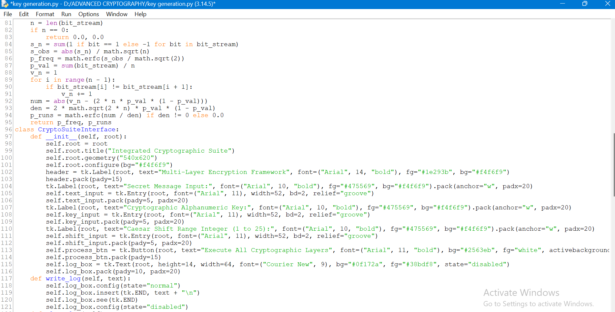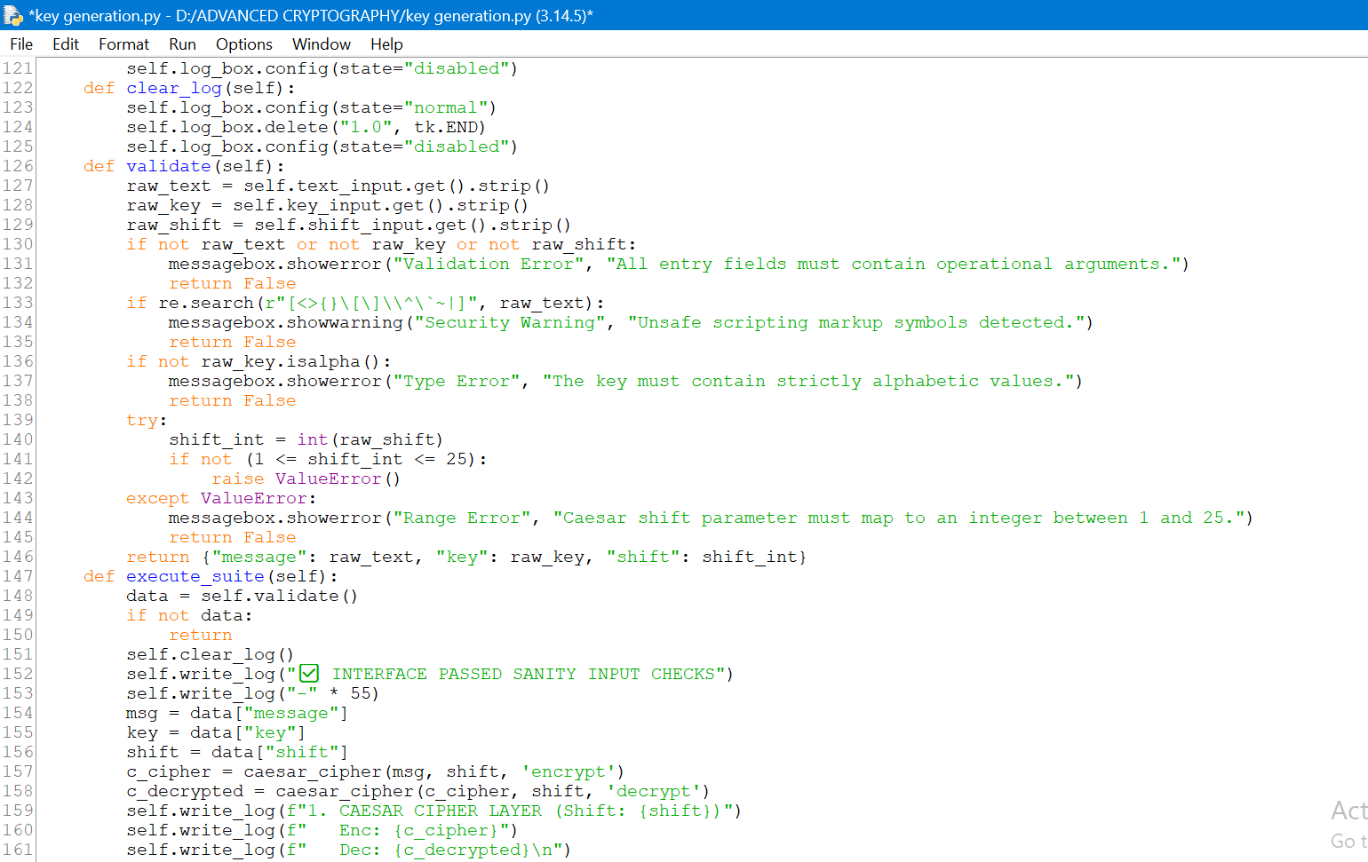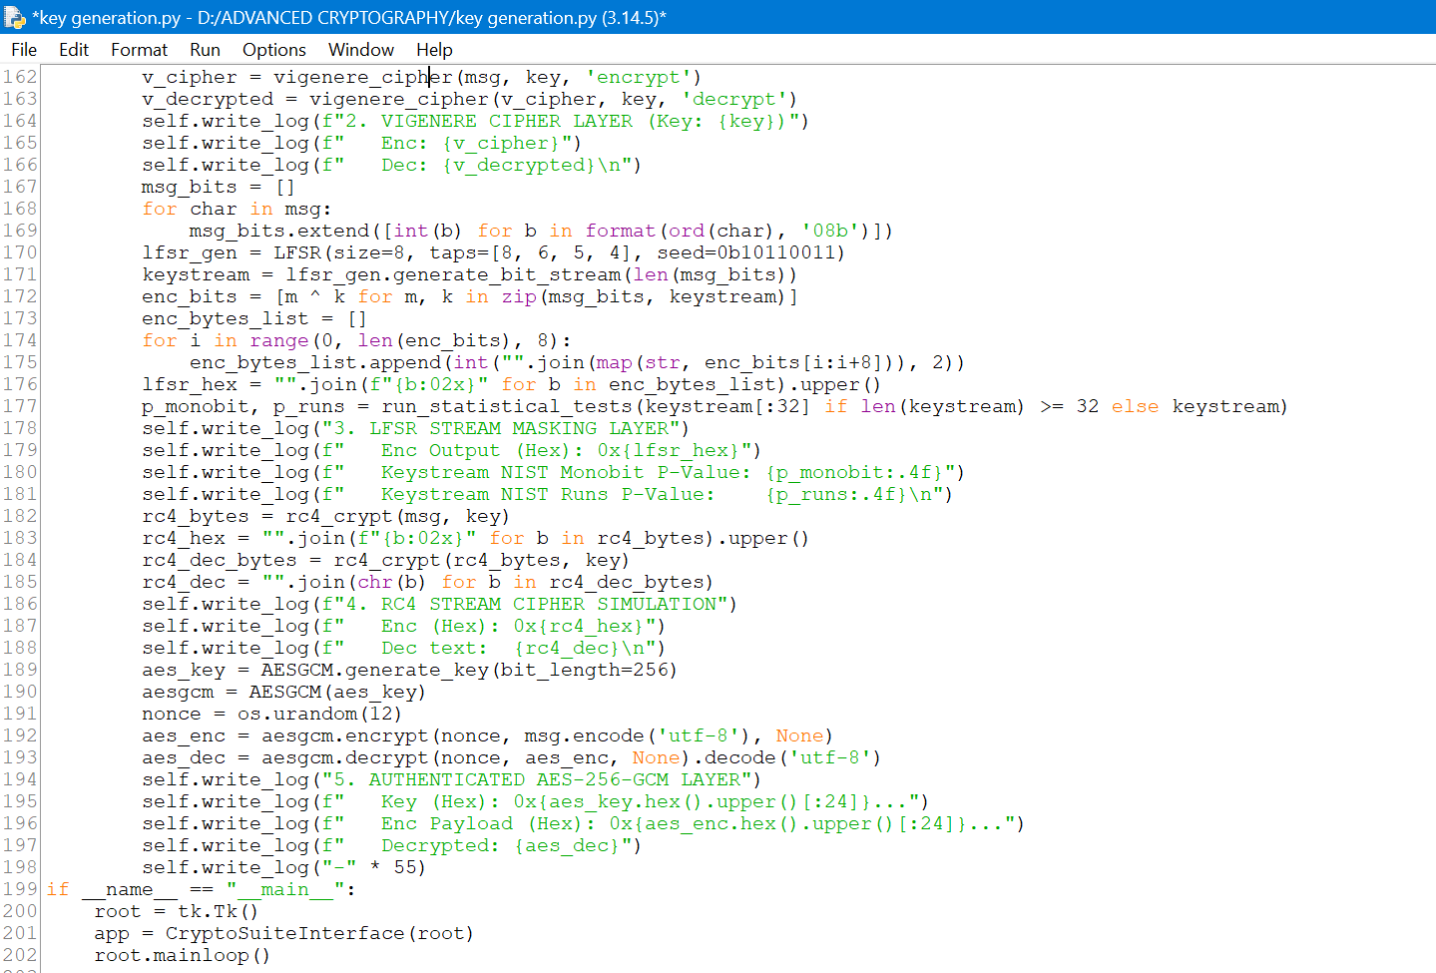
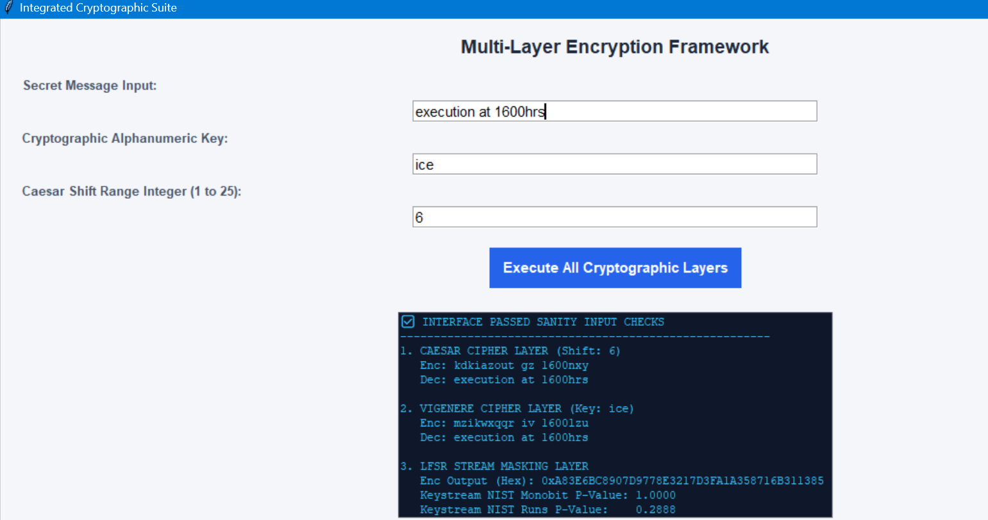
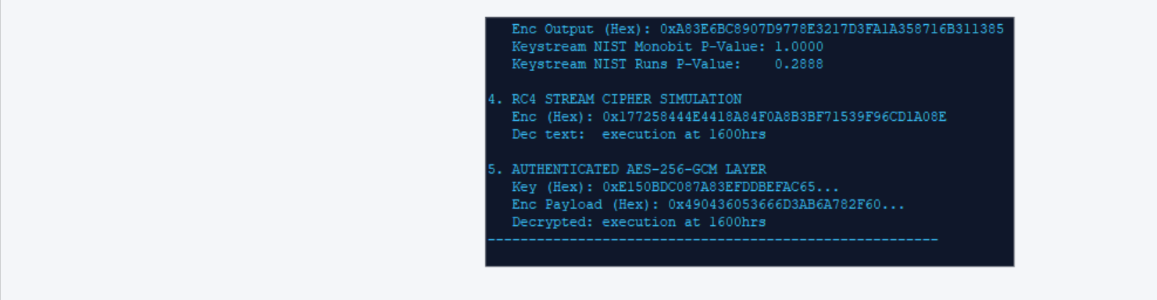

Fig 3: File Encryption Demonstration
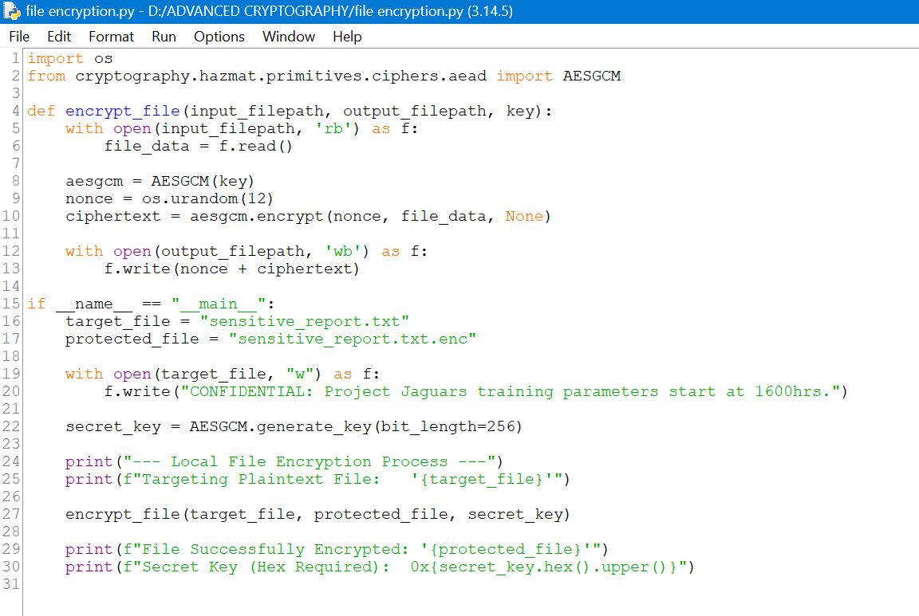
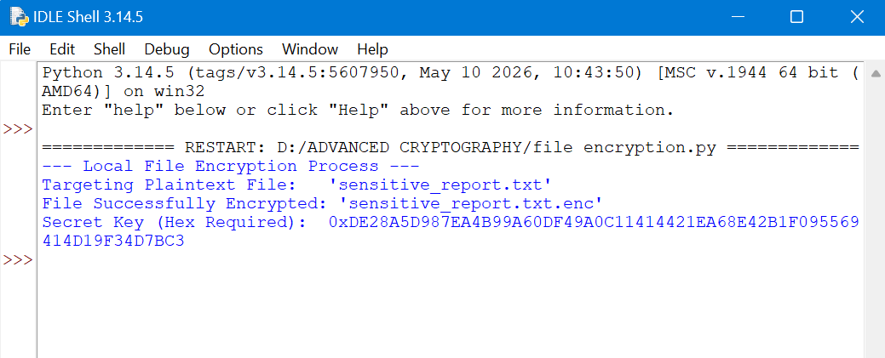

Fig 4: Decryption Results
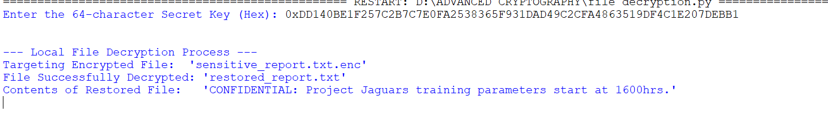

Fig 5: AES Performance Testing

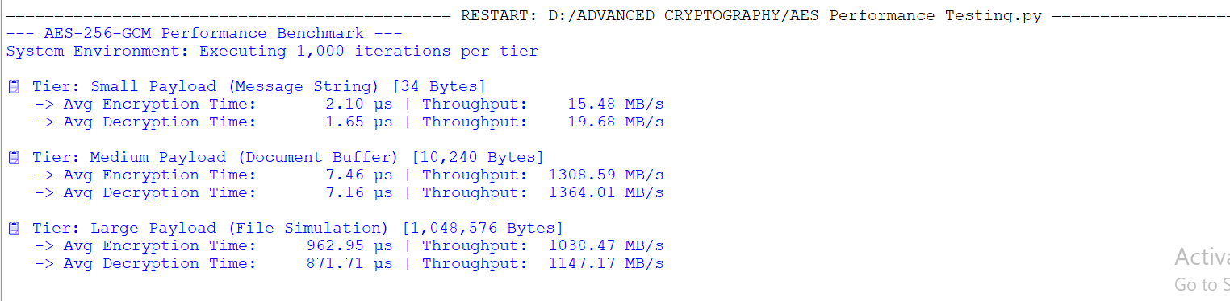

Week 5: Public Key Cryptography (RSA)

Implementation of RSA Encryption and Key Management

Fig 1: RSA Key Pair Generation

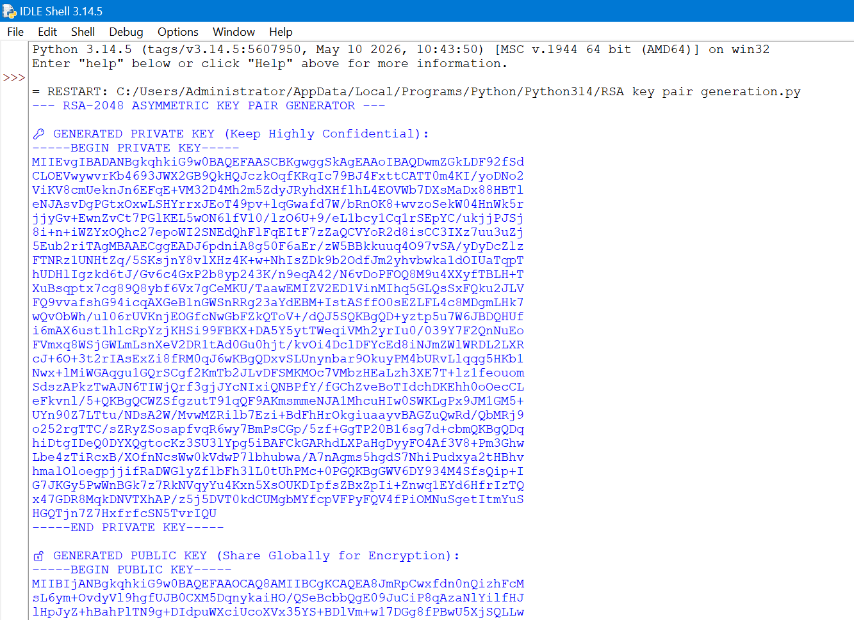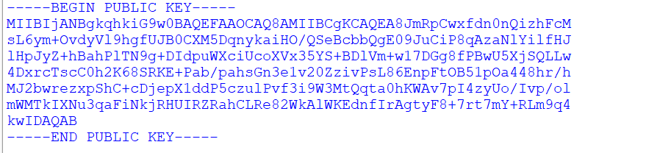

Fig 2: Public Key Encryption Process
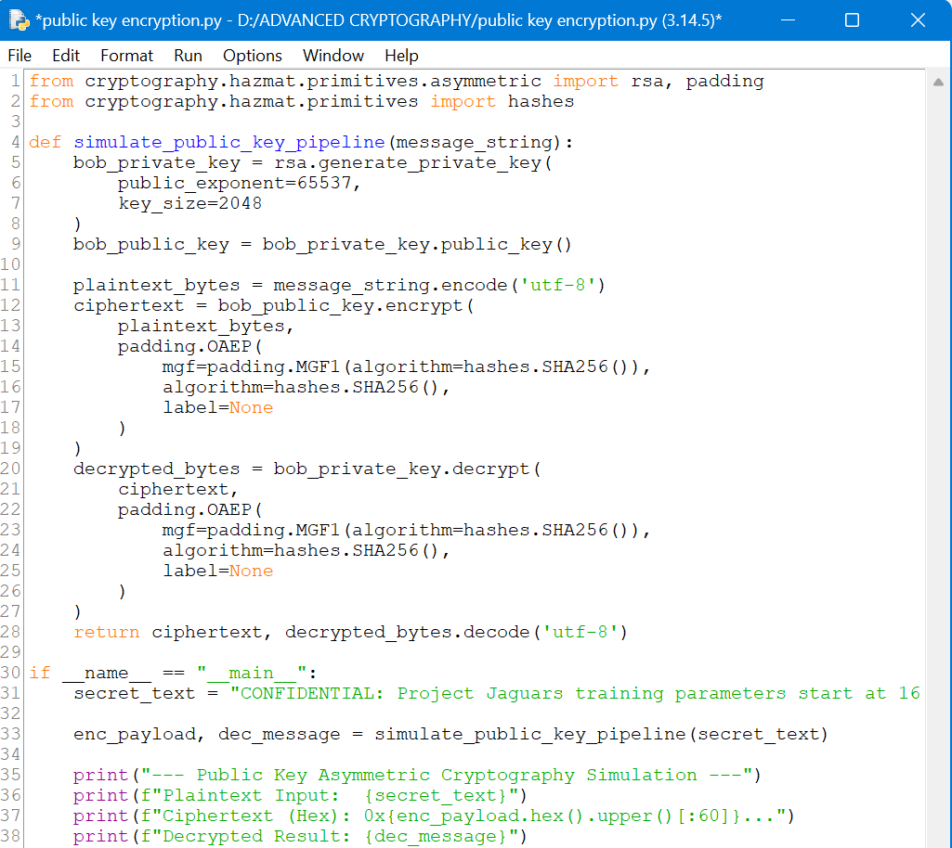
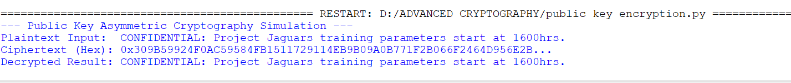

Fig 3: Private Key Decryption Results
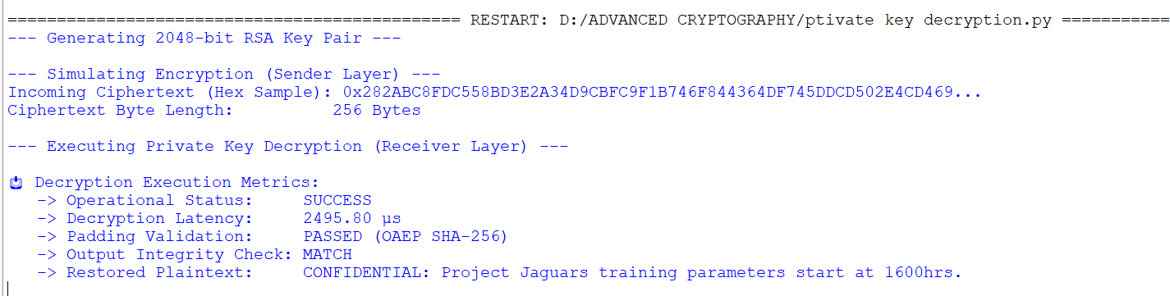

Fig 4: Secure Message Transmission
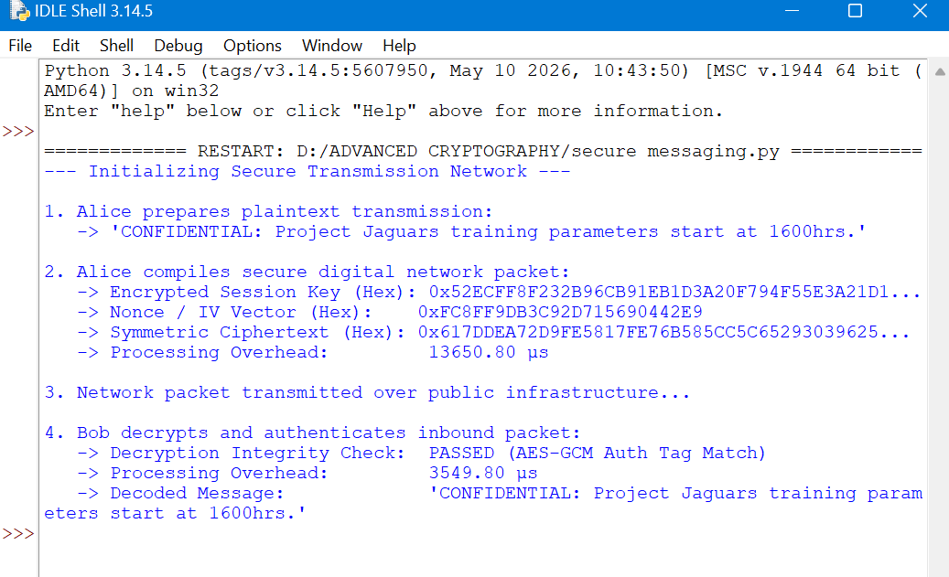

Fig 5: RSA Testing and Validation

